**Assignment – 3**

**Question 1: Build business logic, object of data=20 (use map, filter and reduce)**

**Code:**

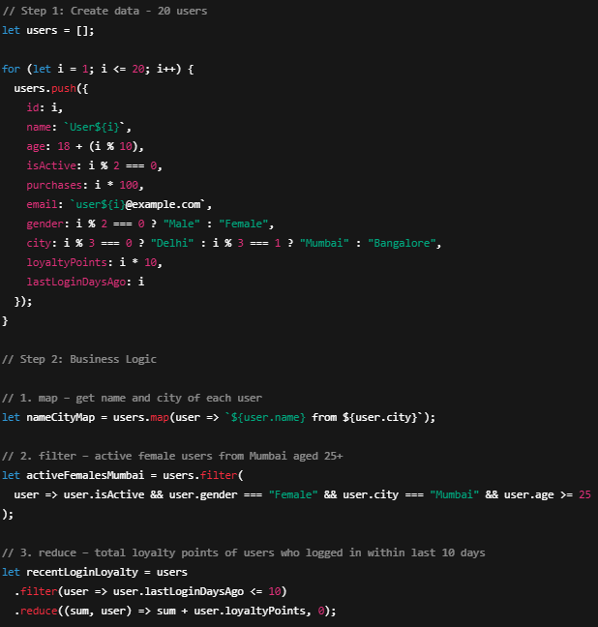

**Output:**

